**CSE 2194: Supervised Machine Learning**

**Lab Assignment-I**

**(Python Basics)**

**Question 1:**

Evaluate the following expressions involving arithmetic operators:

a. -7*20+8/16*2+54

b. 7**2//9%3

c. (7-4*2)*10-25*8//5

d. 5%10+10-25*8//5

e. ’hello’*2-5

Output

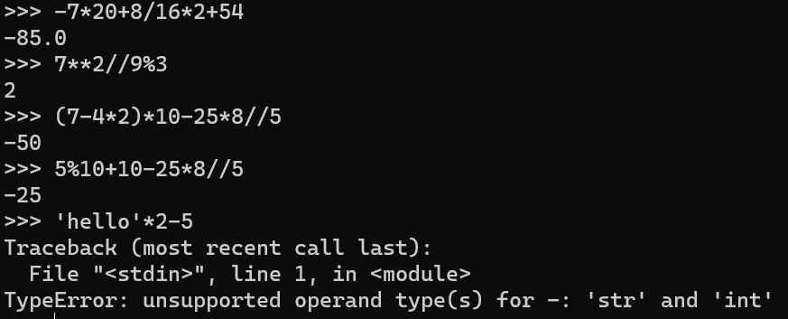

**Question 2:**

Evaluate the following expressions involving relational and logical operators:

a. ’hi’ > ’hello’ and ’bye’ < ’Bye’

b. ’hi’ > ’hello’ or ’bye’ < ’Bye’

c. 7 > 8 or 5 < 6 and ’I am fine’ > ’I am not fine’

d. 10 !=9 and 29 >= 29

e. 10 !=9 and 29 >= 29 and ’hi’ > ’hello’ or ’bye’ < ’Bye’ and 7 <= 2.5

Output

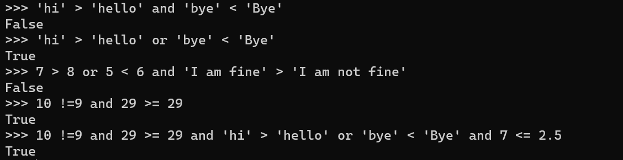

**Question 3:**

Write an assignment statement using a single conditional expression for the following if-else code:

if marks >= 70:

remarks = ’good’

else:

remarks = ’average’

**Output:-**

remarks = 'good' if marks >= 70 else 'average'

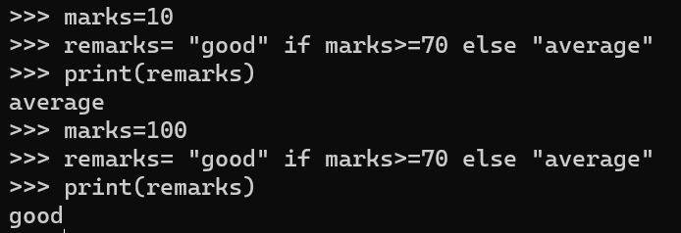

**Question 4:**

Write a Python program to find the sum of all elements in a list.

**Code:-**

def sum(lst):

total = 0

for num in lst:

total += num

return total

m = [1, 2, 3, 4, 5]

print("Sum of all elements in the list:", sum(m))

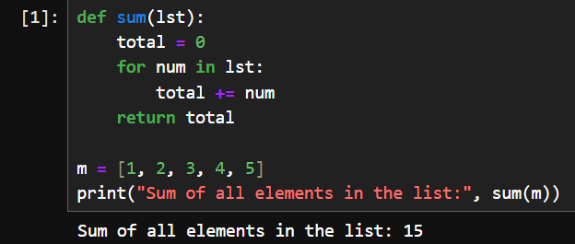

**Question 5:**

Write a Python program that takes two numbers as input parameters and returns their greatest common divisor.

**Code:-**

def hcf(a, b):

if(b == 0):

return a

else:

return hcf(b, a % b)

a = 60

b = 48

# prints 12

print("The gcd of 60 and 48 is : ")

print(hcf(60, 48))

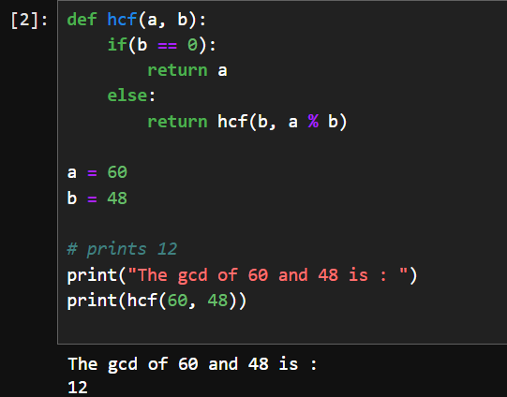

**Question 6:**

Write a Python program to find the maximum of three numbers using a nested function.

**Code without nested function:**

def maximum(num1, num2, num3):

max=0.0

if(num1>num2):

if(num1>num3):

max=num1

else:

max=num3

else:

if(num2>num3):

max=num2

else:

max=num3

return max

# Example usage:

number1 = float(input("Enter the first number: "))

number2 = float(input("Enter the second number: "))

number3 = float(input("Enter the third number: "))

max1 = maximum(number1, number2, number3)

print("The maximum of the three numbers is:", max1)

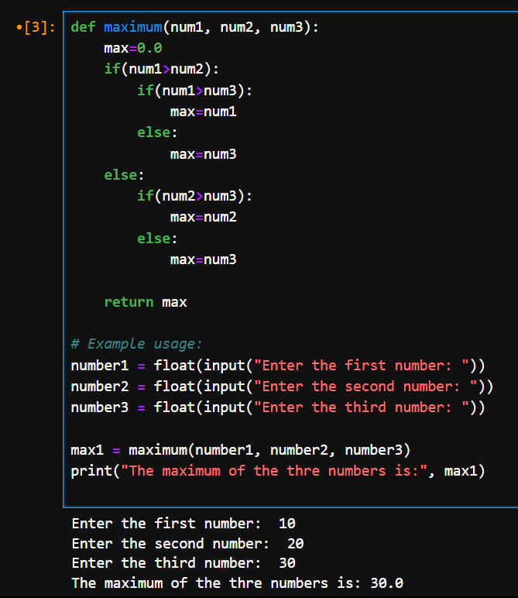

**Code with nested function:**

def find_maximum_of_three(num1, num2, num3):

#nested functions

def find_maximum(x, y):

return x if x > y else y

max_of_first_two = find_maximum(num1, num2)

overall_max = find_maximum(max_of_first_two, num3)

return overall_max

# Example usage:

number1 = float(input("Enter the first number: "))

number2 = float(input("Enter the second number: "))

number3 = float(input("Enter the third number: "))

maximum = find_maximum_of_three(number1, number2, number3)

print("The maximum of the three numbers is:", maximum)

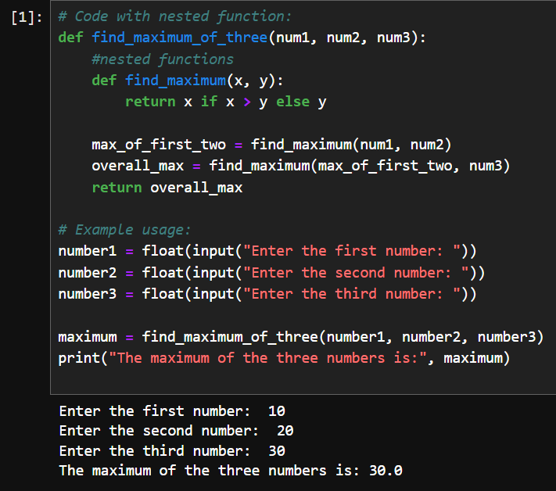

**Question 7:**

Write a Python program to find the maximum element in a list.

**Code**

a=[11,2,3,4,5]

max=a[0]

for i in range(len(a)):

if(max<a[i]):

max=a[i]

print(max)

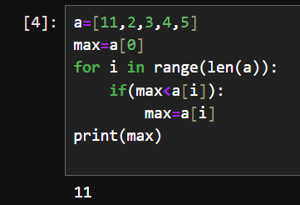

**Question 8:**

An integer n is divisible by 9 if the sum of its digits is divisible by 9. Use this concept in your program to determine whether or not the number is divisible by 9. Use while loop.

Test it on the following number:

n = 154368

Hint: Use the % operator to get each digit, then use the / operator to remove the digit.

Sample run 1: Enter a number: 154368 The number 154368 is divisible by 9.

**Code:**

num=int(input('enter the number'))

sum=0

while(num!=0):

sum=sum + int(num%10)

num=int(num/10)

if(sum%9==0):

print('numer is divisible')

else:

print('numer is not divisible')

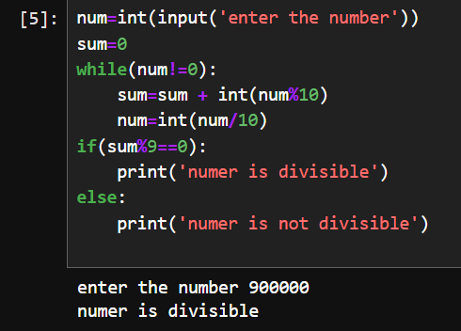

**Question 9:**

Write a Python program that reads an integer between 0 and 1000 and adds all the digits in the integer.

For example, if an integer is 749, the sum of all its digits is 20.

Hint: Use the % operator to extract digits and the / operator to remove the extracted digit.

For instance, 749 % 10 = 9 and 749 / 10 = 74.

Here is a sample run: Enter a number between 0 and 1000: 999 The sum of the digits is 27

**Code**

num=int(input('enter the number'))

sum=0

while(num!=0):

sum=sum + int(num%10)

num=int(num/10)

print(sum)

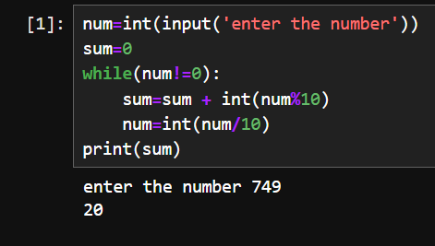

**Question 10:**

Write a Python program to enter the first number and second number. Display the prime number between the first and second numbers.

**Example:**

Enter the first number: 5

Enter the second number: 15

Expected output: 5 7 11 13

**Code:**

def is_prime(n):

if n <= 1:

return False

elif n <= 3:

return True

elif n % 2 == 0 or n % 3 == 0:

return False

i = 5

while i * i <= n:

if n % i == 0 or n % (i + 2) == 0:

return False

i += 6

return True

def display_prime_numbers(start, end):

print("Prime numbers between", start, "and", end, "are:")

for num in range(start, end + 1):

if is_prime(num):

print(num, end=" ")

# Taking input from the user

first_number = int(input("Enter the first number: "))

second_number = int(input("Enter the second number: "))

# Displaying prime numbers between the given range

display_prime_numbers(first_number, second_number)

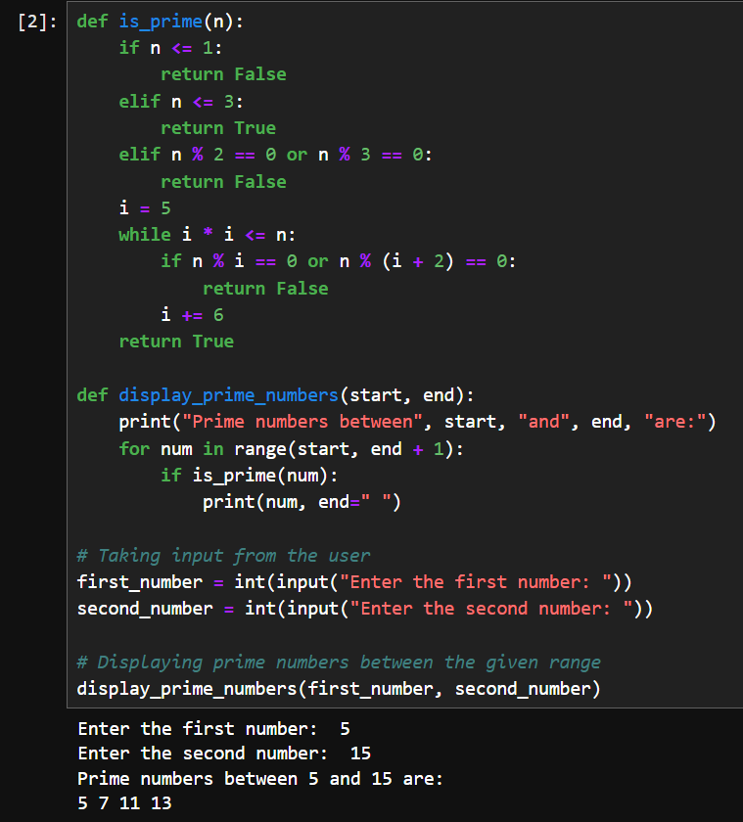

**Lab Assignment to be done by students:**

**Question 1:**

Write a Python program that takes a point's x – y coordinates in the Cartesian plane and prints a message telling either an axis on which the point lies or the quadrant in which it is found.

Here is the sample output:

(-1.0, -2.5) is in quadrant III

(0.0, 4.8) is on the y-axis.

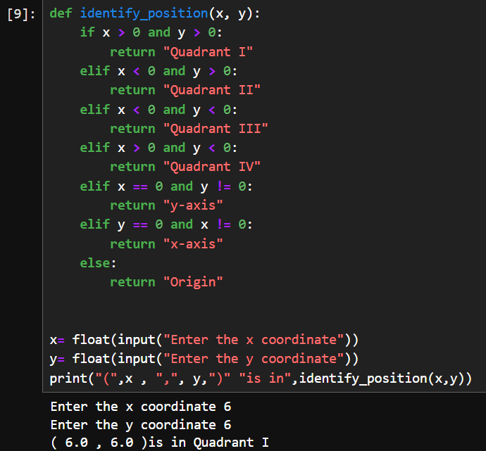

**Question 2:**

Write a Python program to check if a number is a perfect number or not.

(Hints: A number N is called a perfect number if the sum of factors except N as a factor equals the number N. )

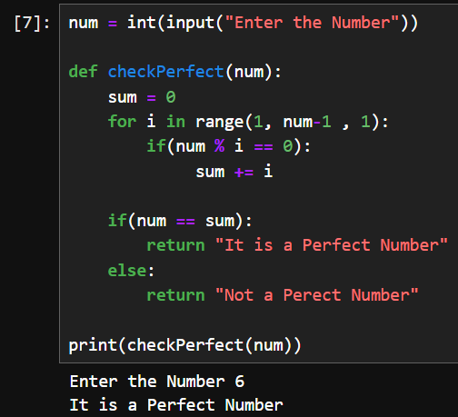

**Question 3:**

Write a Python program to print fibonacci series up to the given n-th term.

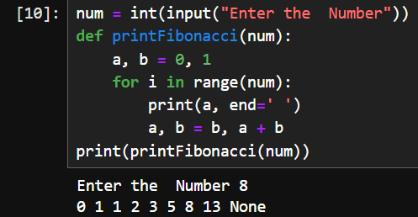

**Question 4:**

Write a Python program for a given string as input, find out if it’s a palindrome or not.

